Understanding Logistic Regression
Pre-requisite: Linear Regression
This article discusses the basics of Logistic Regression and its implementation in Python. Logistic regression is basically a supervised classification algorithm. In a classification problem, the target variable(or output), y, can take only discrete values for a given set of features(or inputs), X.
Contrary to popular belief, logistic regression IS a regression model. The model builds a regression model to predict the probability that a given data entry belongs to the category numbered as “1”. Just like Linear regression assumes that the data follows a linear function, Logistic regression models the data using the sigmoid function.

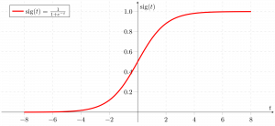
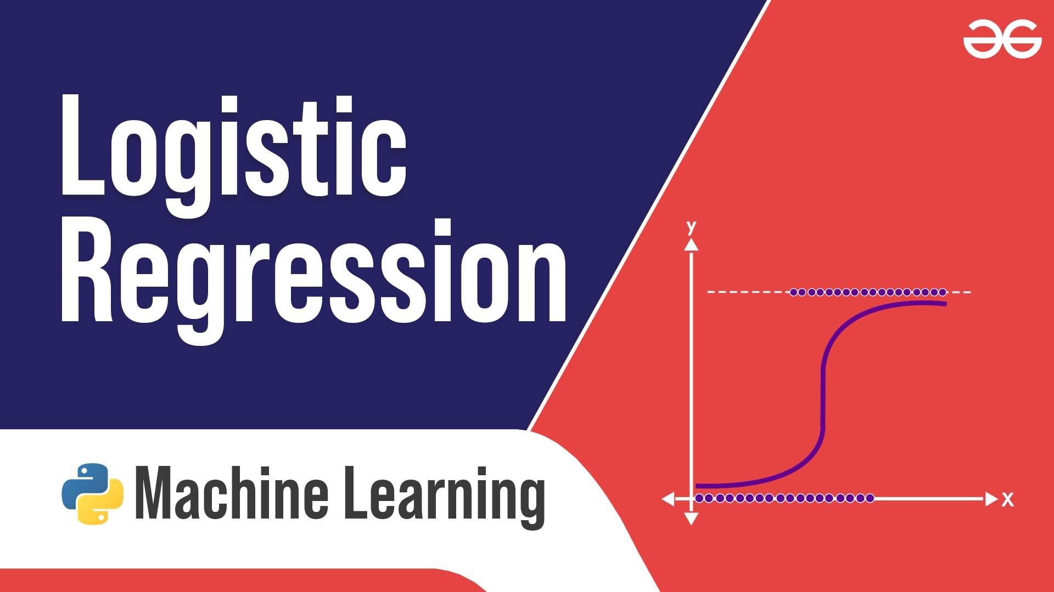
Logistic regression becomes a classification technique only when a decision threshold is brought into the picture. The setting of the threshold value is a very important aspect of Logistic regression and is dependent on the classification problem itself.
The decision for the value of the threshold value is majorly affected by the values of precision and recall. Ideally, we want both precision and recall to be 1, but this seldom is the case.

ML | Why Logistic Regression in Classification ?
Using Linear Regression, all predictions >= 0.5 can be considered as 1 and rest all < 0.5 can be considered as 0. But then the question arises why classification can’t be performed using it?

Problem –
Suppose we are classifying a mail as spam or not spam and our output is y, it can be 0(spam) or 1(not spam). In case of Linear Regression, hθ(x) can be > 1 or < 0. Although our prediction should be in between 0 and 1, the model will predict value out of the range i.e. maybe > 1 or < 0.
So, that’s why for a Classification task, Logistic/Sigmoid Regression plays its role.
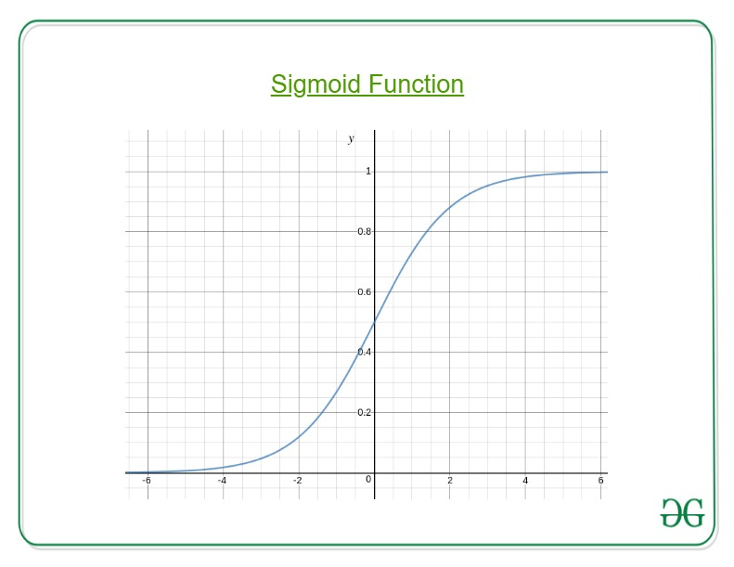
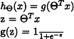
Here, we plug θTx into logistic function where θ are the weights/parameters and x is the input and hθ(x) is the hypothesis function. g() is the sigmoid function.
It means that y = 1 probability when x is parameterized to θ
To get the discrete values 0 or 1 for classification, discrete boundaries are defined. The hypothesis function cab be translated as
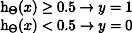
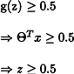
Decision Boundary is the line that distinguishes the area where y=0 and where y=1. These decision boundaries result from the hypothesis function under consideration.
Understanding Decision Boundary with an example –
Let our hypothesis function be
Then the decision boundary looks like
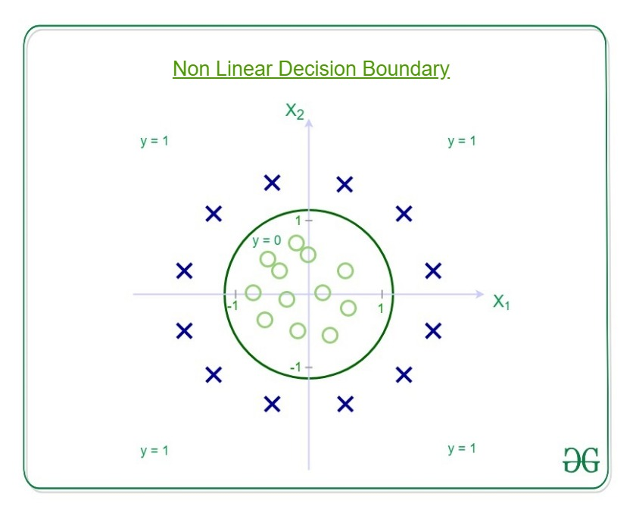
Let out weights or parameters be –
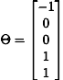
So, it predicts y = 1 if
And that is the equation of a circle with radius = 1 and origin as the center. This is the Decision Boundary for our defined hypothesis.

ML | Logistic Regression using Tensorflow
Prerequisites: Understanding Logistic Regression and TensorFlow.

Brief Summary of Logistic Regression:
Logistic Regression is Classification algorithm commonly used in Machine Learning. It allows categorizing data into discrete classes by learning the relationship from a given set of labeled data. It learns a linear relationship from the given dataset and then introduces a non-linearity in the form of the Sigmoid function.
In case of Logistic regression, the hypothesis is the Sigmoid of a straight line, i.e,
where
Where the vector w represents the Weights and the scalar b represents the Bias of the model.
Let us visualize the Sigmoid Function –
import numpy as np
import matplotlib.pyplot as plt

def sigmoid(z):
return 1 / (1 + np.exp( - z))

plt.plot(np.arange(-5, 5, 0.1), sigmoid(np.arange(-5, 5, 0.1)))
plt.title('Visualization of the Sigmoid Function')

plt.show()

Output:
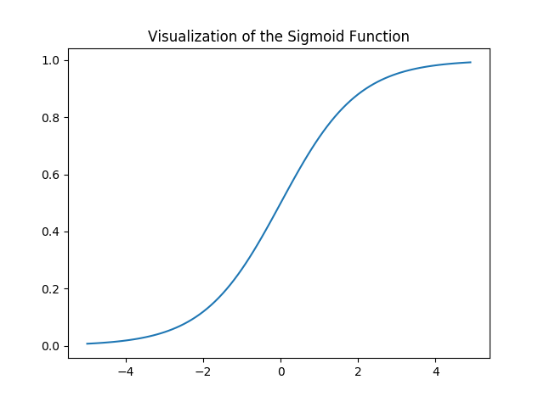
Note that the range of the Sigmoid function is (0, 1) which means that the resultant values are in between 0 and 1. This property of Sigmoid function makes it a really good choice of Activation Function for Binary Classification. Also for z = 0, Sigmoid(z) = 0.5 which is the midpoint of the range of Sigmoid function.
Just like Linear Regression, we need to find the optimal values of w and b for which the cost function J is minimum. In this case, we will be using the Sigmoid Cross Entropy cost function which is given by
This cost function will then be optimized using Gradient Descent.
Implementation:
We will start by importing the necessary libraries. We will use Numpy along with Tensorflow for computations, Pandas for basic Data Analysis and Matplotlib for plotting. We will also be using the preprocessing module of Scikit-Learn for One Hot Encoding the data.
# importing modules
import numpy as np
import pandas as pd
import tensorflow as tf
import matplotlib.pyplot as plt
from sklearn.preprocessing import OneHotEncoder

Next we will be importing the dataset. We will be using a subset of the famous Iris dataset.
data = pd.read_csv('dataset.csv', header = None)
print("Data Shape:", data.shape)

print(data.head())

Output:
Data Shape: (100, 4)
0 1 2 3
0 0 5.1 3.5 1
1 1 4.9 3.0 1
2 2 4.7 3.2 1
3 3 4.6 3.1 1
4 4 5.0 3.6 1
Now let’s get the feature matrix and the corresponding labels and visualize.
# Feature Matrix
x_orig = data.iloc[:, 1:-1].values

# Data labels
y_orig = data.iloc[:, -1:].values

print("Shape of Feature Matrix:", x_orig.shape)
print("Shape Label Vector:", y_orig.shape)

Output:
Shape of Feature Matrix: (100, 2)
Shape Label Vector: (100, 1)
Visualize the given data.
# Positive Data Points
x_pos = np.array([x_orig[i] for i in range(len(x_orig))
if y_orig[i] == 1])

# Negative Data Points
x_neg = np.array([x_orig[i] for i in range(len(x_orig))
if y_orig[i] == 0])

# Plotting the Positive Data Points
plt.scatter(x_pos[:, 0], x_pos[:, 1], color = 'blue', label = 'Positive')

# Plotting the Negative Data Points
plt.scatter(x_neg[:, 0], x_neg[:, 1], color = 'red', label = 'Negative')

plt.xlabel('Feature 1')
plt.ylabel('Feature 2')
plt.title('Plot of given data')
plt.legend()

plt.show()

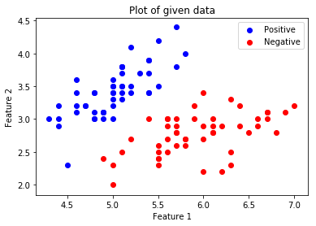.
Now we will be One Hot Encoding the data for it to work with the algorithm. One hot encoding transforms categorical features to a format that works better with classification and regression algorithms. We will also be setting the Learning Rate and the number of Epochs.
# Creating the One Hot Encoder
oneHot = OneHotEncoder()

# Encoding x_orig
oneHot.fit(x_orig)
x = oneHot.transform(x_orig).toarray()

# Encoding y_orig
oneHot.fit(y_orig)
y = oneHot.transform(y_orig).toarray()

alpha, epochs = 0.0035, 500
m, n = x.shape
print('m =', m)
print('n =', n)
print('Learning Rate =', alpha)
print('Number of Epochs =', epochs)

Output:
m = 100
n = 7
Learning Rate = 0.0035
Number of Epochs = 500
Now we will start creating the model by defining the placeholders X and Y, so that we can feed our training examples x and y into the optimizer during the training process. We will also be creating the trainable Variables W and b which can be optimized by the Gradient Descent Optimizer.
# There are n columns in the feature matrix
# after One Hot Encoding.
X = tf.placeholder(tf.float32, [None, n])

# Since this is a binary classification problem,
# Y can take only 2 values.
Y = tf.placeholder(tf.float32, [None, 2])

# Trainable Variable Weights
W = tf.Variable(tf.zeros([n, 2]))

# Trainable Variable Bias
b = tf.Variable(tf.zeros([2]))

Now declare the Hypothesis, Cost function, Optimizer and Global Variables Initializer.
# Hypothesis
Y_hat = tf.nn.sigmoid(tf.add(tf.matmul(X, W), b))

# Sigmoid Cross Entropy Cost Function
cost = tf.nn.sigmoid_cross_entropy_with_logits(
logits = Y_hat, labels = Y)

# Gradient Descent Optimizer
optimizer = tf.train.GradientDescentOptimizer(
learning_rate = alpha).minimize(cost)

# Global Variables Initializer
init = tf.global_variables_initializer()

Begin the training process inside a Tensorflow Session.
# Starting the Tensorflow Session
with tf.Session() as sess:

# Initializing the Variables
sess.run(init)

# Lists for storing the changing Cost and Accuracy in every Epoch
cost_history, accuracy_history = [], []

# Iterating through all the epochs
for epoch in range(epochs):
cost_per_epoch = 0

# Running the Optimizer
sess.run(optimizer, feed_dict = {X : x, Y : y})

# Calculating cost on current Epoch
c = sess.run(cost, feed_dict = {X : x, Y : y})

# Calculating accuracy on current Epoch
correct_prediction = tf.equal(tf.argmax(Y_hat, 1),
tf.argmax(Y, 1))
accuracy = tf.reduce_mean(tf.cast(correct_prediction,
tf.float32))

# Storing Cost and Accuracy to the history
cost_history.append(sum(sum(c)))
accuracy_history.append(accuracy.eval({X : x, Y : y}) * 100)

# Displaying result on current Epoch
if epoch % 100 == 0 and epoch != 0:
print("Epoch " + str(epoch) + " Cost: "
+ str(cost_history[-1]))

Weight = sess.run(W) # Optimized Weight
Bias = sess.run(b) # Optimized Bias

# Final Accuracy
correct_prediction = tf.equal(tf.argmax(Y_hat, 1),
tf.argmax(Y, 1))
accuracy = tf.reduce_mean(tf.cast(correct_prediction,
tf.float32))
print("\nAccuracy:", accuracy_history[-1], "%")

Output:
Epoch 100 Cost: 125.700202942
Epoch 200 Cost: 120.647117615
Epoch 300 Cost: 118.151592255
Epoch 400 Cost: 116.549999237

Accuracy: 91.0000026226 %
Let’s plot the change of cost over the epochs.
plt.plot(list(range(epochs)), cost_history)
plt.xlabel('Epochs')
plt.ylabel('Cost')
plt.title('Decrease in Cost with Epochs')

plt.show()

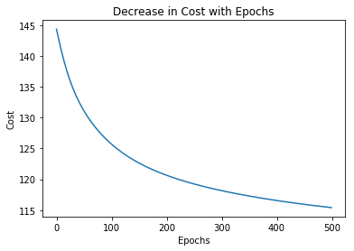
Plot the change of accuracy over the epochs.
plt.plot(list(range(epochs)), accuracy_history)
plt.xlabel('Epochs')
plt.ylabel('Accuracy')
plt.title('Increase in Accuracy with Epochs')

plt.show()

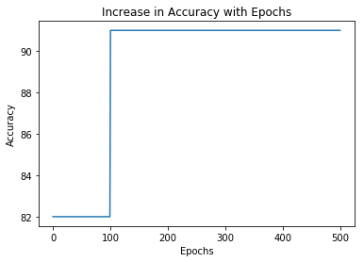
Now we will be plotting the Decision Boundary for our trained classifier. A decision boundary is a hypersurface that partitions the underlying vector space into two sets, one for each class.
# Calculating the Decision Boundary
decision_boundary_x = np.array([np.min(x_orig[:, 0]),
np.max(x_orig[:, 0])])

decision_boundary_y = (- 1.0 / Weight[0]) *
(decision_boundary_x * Weight + Bias)

decision_boundary_y = [sum(decision_boundary_y[:, 0]),
sum(decision_boundary_y[:, 1])]

# Positive Data Points
x_pos = np.array([x_orig[i] for i in range(len(x_orig))
if y_orig[i] == 1])

# Negative Data Points
x_neg = np.array([x_orig[i] for i in range(len(x_orig))
if y_orig[i] == 0])

# Plotting the Positive Data Points
plt.scatter(x_pos[:, 0], x_pos[:, 1],
color = 'blue', label = 'Positive')

# Plotting the Negative Data Points
plt.scatter(x_neg[:, 0], x_neg[:, 1],
color = 'red', label = 'Negative')

# Plotting the Decision Boundary
plt.plot(decision_boundary_x, decision_boundary_y)
plt.xlabel('Feature 1')
plt.ylabel('Feature 2')
plt.title('Plot of Decision Boundary')
plt.legend()

plt.show()

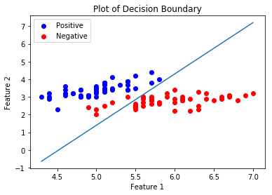

ML | Cost function in Logistic Regression
In the case of Linear Regression, the Cost function is –

But for Logistic Regression,
It will result in a non-convex cost function. But this results in cost function with local optima’s which is a very big problem for Gradient Descent to compute the global optima.
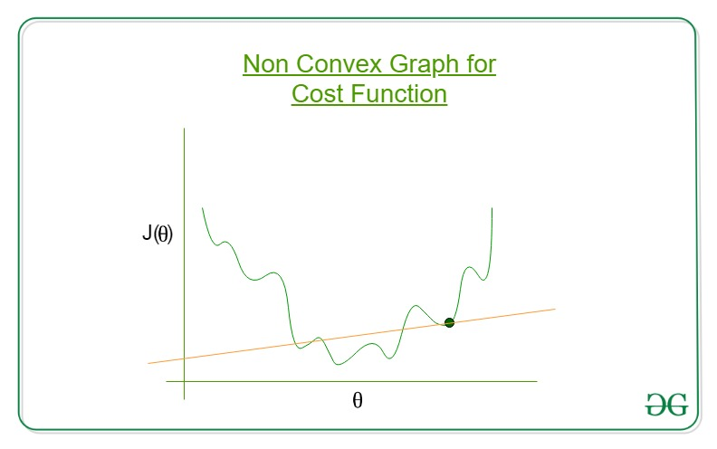
So, for Logistic Regression the cost function is
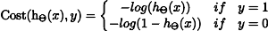
If y = 1
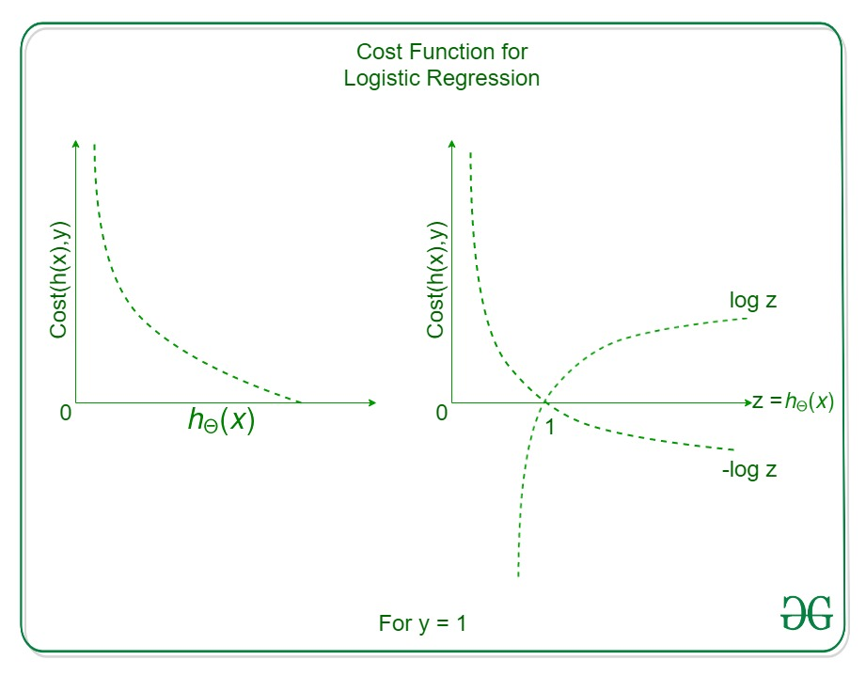
Cost = 0 if y = 1, hθ(x) = 1
But as,
hθ(x) -> 0
Cost -> Infinity
If y = 0
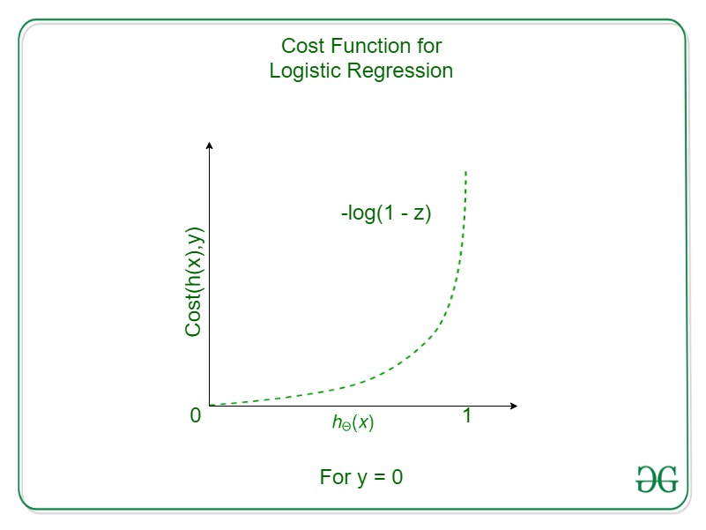
So,
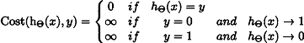
To fit parameter θ, J(θ) has to be minimized and for that Gradient Descent is required.
Gradient Descent – Looks similar to that of Linear Regression but the difference lies in the hypothesis hθ(x)

ML | Logistic Regression using Python
User Database – This dataset contains information about users from a company’s database. It contains information about UserID, Gender, Age, EstimatedSalary, and Purchased. We are using this dataset for predicting whether a user will purchase the company’s newly launched product or not.

Prerequisite: Understanding Logistic Regression
Do refer to the below table from where data is being fetched from the dataset.
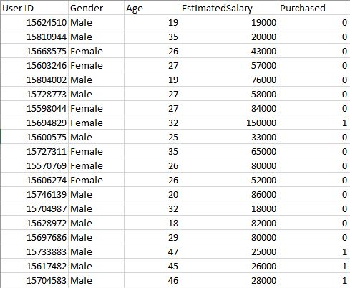
Let us make the Logistic Regression model, predicting whether a user will purchase the product or not.
Inputting Libraries.

Import Libraries
import pandas as pd
import numpy as np
import matplotlib.pyplot as plt

Read and Explore the data

dataset = pd.read_csv("User_Data.csv")

Now, to predict whether a user will purchase the product or not, one needs to find out the relationship between Age and Estimated Salary. Here User ID and Gender are not important factors for finding out this.

# input
x = dataset.iloc[:, [2, 3]].values

# output
y = dataset.iloc[:, 4].values

Splitting The Dataset: Train and Test dataset
Splitting the dataset to train and test. 75% of data is used for training the model and 25% of it is used to test the performance of our model.

from sklearn.model_selection import train_test_split
X_train, X_test, y_train, y_test = train_test_split(x, y, test_size = 0.25, random_state = 0)

Now, it is very important to perform feature scaling here because Age and Estimated Salary values lie in different ranges. If we don’t scale the features then the Estimated Salary feature will dominate the Age feature when the model finds the nearest neighbor to a data point in the data space.

from sklearn.preprocessing import StandardScaler
sc_x = StandardScaler()
xtrain = sc_x.fit_transform(xtrain)
xtest = sc_x.transform(xtest)

print (xtrain[0:10, :])

Output:
[[ 0.58164944 -0.88670699]
[-0.60673761 1.46173768]
[-0.01254409 -0.5677824 ]
[-0.60673761 1.89663484]
[ 1.37390747 -1.40858358]
[ 1.47293972 0.99784738]
[ 0.08648817 -0.79972756]
[-0.01254409 -0.24885782]
[-0.21060859 -0.5677824 ]
[-0.21060859 -0.19087153]]
Here once see that Age and Estimated salary features values are scaled and now there in the -1 to 1. Hence, each feature will contribute equally to decision making i.e. finalizing the hypothesis.
Finally, we are training our Logistic Regression model.

Train The Model

from sklearn.linear_model import LogisticRegression
classifier = LogisticRegression(random_state = 0)
classifier.fit(xtrain, ytrain)

After training the model, it is time to use it to do predictions on testing data.

y_pred = classifier.predict(xtest)

Let’s test the performance of our model – Confusion Matrix

Evaluation Metrics
Metrics are used to check the model performance on predicted values and actual values.

from sklearn.metrics import confusion_matrix
cm = confusion_matrix(ytest, y_pred)

print ("Confusion Matrix : \n", cm)

Output:
Confusion Matrix :
[[65 3]
[ 8 24]]
Out of 100 :
True Positive + True Negative = 65 + 24
False Positive + False Negative = 3 + 8
Performance measure – Accuracy
Example

from sklearn.metrics import accuracy_score
print ("Accuracy : ", accuracy_score(ytest, y_pred))

Output:
Accuracy : 0.89

Visualizing the performance of our model.

from matplotlib.colors import ListedColormap
X_set, y_set = xtest, ytest
X1, X2 = np.meshgrid(np.arange(start = X_set[:, 0].min() - 1,
stop = X_set[:, 0].max() + 1, step = 0.01),
np.arange(start = X_set[:, 1].min() - 1,
stop = X_set[:, 1].max() + 1, step = 0.01))

plt.contourf(X1, X2, classifier.predict(
np.array([X1.ravel(), X2.ravel()]).T).reshape(
X1.shape), alpha = 0.75, cmap = ListedColormap(('red', 'green')))

plt.xlim(X1.min(), X1.max())
plt.ylim(X2.min(), X2.max())

for i, j in enumerate(np.unique(y_set)):
plt.scatter(X_set[y_set == j, 0], X_set[y_set == j, 1],
c = ListedColormap(('red', 'green'))(i), label = j)

plt.title('Classifier (Test set)')
plt.xlabel('Age')
plt.ylabel('Estimated Salary')
plt.legend()
plt.show()

Output:
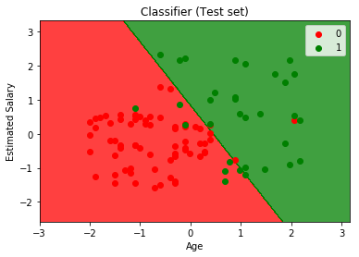
Analyzing the performance measures – accuracy and confusion matrix and the graph, we can clearly say that our model is performing really well.

